The Podcast is Coming From Inside the House! Show Note
Episode 2, Parts I & II: The Haunted Plantation
* Special thanks to the CAPS team, including Tina, Jeff, Ashe, Bryan, Ishmael, and
others. We appreciate your time, hospitality, historical knowledge and for allowing
us to be a part of this event. *
If you’re interested in learning more about Charlotte Area Paranormal Society, visit their website here: https://www.charlotteareaparanormal.org
CAPS on Facebook: https://www.facebook.com/CAPSNC/
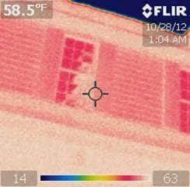
FLIR Image referenced in Episode:

Picture courtesy of Charlotte Area
Paranormal Society (CAPS)

Further Reading About Rosedale Plantation:
https://www.historicrosedale.org
https://tinyurl.com/yc85tor2

